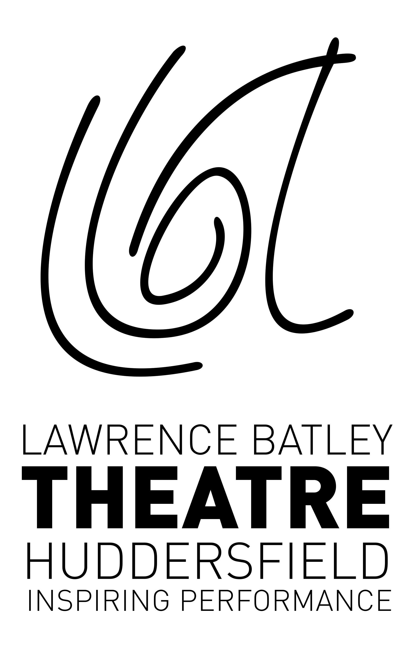
Lawrence Batley Theatre
Queen’s Square
Queen Street
Huddersfield
HD1 2SP

CONTACT for interviews, images and further information:
Laura Rodwell, Lawrence Batley Theatre
01484 484402 / laura@thelbt.org

Debbie Pett, Anita Morris Associates
01943 603311 / debbie@anitamorrisassociates.co.uk

PRESS RELEASE

CAST NAMED FOR WORLD PREMIERE OF LOST BOY RACER

The LAWRENCE BATLEY THEATRE is thrilled to announce that THOMAS ALDERSLEY, ROBIN SIMPSON, SARAH GROARKE, MICHAELA LONGDEN and SEAN KING will take the lead roles in the specially written show in celebration of the Grand Départ of the 2014 Tour de France, LOST BOY RACER.

LOST BOY RACER holds its WORLD PREMIERE at the LAWRENCE BATLEY THEATRE HUDDERSFIELD (the LBT) on WEDNESDAY 25 JUNE and runs until FRIDAY 27 JUNE before touring. Written by local writer Julie Bokowiec, the show follows the story of Sean Racer, who used to be an energetic wildcat youth hooked on cycling. Now he's an overweight, 40-something tax inspector on the brink of a personal crisis.

Turning to Claude, an oddball ex-pro cycle mechanic, and encouraged by the wily Linda, a serial tax evader keen to distract him from taking a closer look at her books, Sean hatches a plan to get his life back on track and on two wheels. He will fulfil a youthful dream; to ride the Tour de France. That's right, he's going the distance, albeit on a bike on rollers in the shed. Will he make it to the finish?

LOST BOY RACER is part of the YORKSHIRE FESTIVAL 2014: the first cultural festival to precede the Tour De France Grand Départ in the race’s 111 year history. LOST BOY RACER was selected from over 400 applications to be part of the festival, and is one of nearly 50 events across Yorkshire that has been specifically commissioned to be part of the programme which runs from 27th March to the 6th July 2014.

Leading the line up and playing Sean Racer is THOMAS ALDERSLEY. Thomas recently played Mikos in the popular television film series Atlantis. He has recently appeared in a number of theatre plays including Once in a House on Fire (The Lowry, Salford Quays), PUB (Royal Exchange, Manchester) and Danny Champion of the World (Octagon Theatre, Bolton). Having grown up in Yorkshire, Thomas spent a lot of time on the Northern comedy circuit before turning to acting as a career.

Taking up the role of Claude is Slaithwaite’s very own ROBIN SIMPSON. Nominated for Best Supporting Actor at the 2014 Manchester Theatre Awards for David Copperfield Robin has previously appeared at the Lawrence Batley Theatre as Sir Henry Baskerville in The Hound of the Baskervilles (Oldham Coliseum/Imitating the Dog/Lawrence Batley Theatre). He has also has appeared in numerous national and touring productions including Bedroom Farce (Oldham Coliseum Theatre/Harrogate Theatre), Grandpa in my Pocket (Nottingham Playhouse & National Tour) and To Kill a Mockingbird (York Theatre Royal/Touring). His television and radio appearances include: Coronation Street, Waterloo Road and The Archers.

Playing Linda is SARAH GROARKE. Sarah trained at the Bristol Old Vic Theatre School, where she was the recipient of the Peter Ackerman Comedy Prize. She has performed in many of the country’s leading theatres with credits including: Macbeth (Southwark Playhouse), Animal Farm (Peter Hall Company) and Oliver! (New Vic Theatre). Her television and film appearances include: Emmerdale, Death by Home, A Quiet Night In and The Shadow of the Vampire.

MICHAELA LONGDEN performs the part of Nina. Michaela is a recent graduate of the Academy of Live and Recorded Arts who is already making a name for herself as an actress of considerable charm, intelligence and talent. She has appeared in Animal Farm and The Tempest (Oldham Coliseum Theatre) and Cannibals (Royal Exchange Theatre, Manchester).

Rounding up the main cast is SEAN KING as Lost Boy. Sean is a physical theatre artist and rock climber who has created and performed his own brand of innovative dance/physical theatre work internationally. King has worked with numerous dance companies, DJs and filmmakers including Bert Van Gorp (Belgium), Sean Tuan John (Wales) and the Seven Sisters group. He co-curated Danceweek (Battersea Arts Centre), Skinshakers (Purcell Rooms), a mixed bill of dance, live music, animation and digital film, and programmed the Bristol EDF Energy Harbourside Dance Stage as part of the Bristol Harbour Festival. He is known for his unique creative development training sessions and his distinctive brand of urban moves.

LOST BOY RACER is a quirky northern comedy-drama with a touch of blood, sweat and tears, a large dose of fun, some off-the-wall bike action and a love story of sorts...

The world premiere comes from the writer and producer of The Last Cuckoo, Julie Amanda Bokowiec; director Liz Postlethwaite; and features an extraordinary set by award winning metal sculptor Tim Tolkien.

After its premiere, the production will travel to The Lowry, Salford Quays (Saturday 28 – Sunday 29 June), Harrogate Theatre (Wednesday 2 – Friday 4 July) and Theatre Royal Wakefield (Monday 7 – Tuesday 8 July).

Tickets for LOST BOY RACER are priced at £14, £12, £10 / concessions £2 off / under 26s £6 and can be purchased from the box office on 01484 430528 or online at www.thelbt.org.

ENDS
CONTACT for interviews, images and further information:

Laura Rodwell, Lawrence Batley Theatre  01484 484402 / laura@thelbt.org | Debbie Pett, Anita Morris Associates  for Yorkshire Festival 2014  01943 603311 / debbie@anitamorrisassociates.co.uk

- LOST BOY RACER
- CAST ANNOUNCEMENT
- WEDNESDAY 25 – FRIDAY 27 JUNE, 7.30PM
- WORLD PREMIERE
- IN CELEBRATION OF LE GRAND DÉPART 2014
- THOMAS ALDERSLEY, ROBIN SIMPSON, SARAH GROARKE, MICHAELA LONGDEN AND SEAN KING
- LOST BOY RACER is part of the Yorkshire Festival 2014; the official festival in commemoration of theTour de France Grand Départ. The festival will take place across the whole county from Thursday 27 March – Sunday 6 July and will feature nearly 50 events across all art forms.
Yorkshire Festival 2014 is the first ever arts festival to precede the Grand Départ in its 111 year history.
Visit www.yorkshirefestival.co.uk, ‘Yorkshire Festival’ on Facebook or follow Yorkshire Festival 2014 on Twitter with @YFest2014
- Production website: www.juliebokowiec.com/lost-boy-racer.html
- BOX OFFICE 01484 430528
- ONLINE www.thelbt.org

